atama-ii-books.com

About the Atama-ii interactive book series

This new ebook series from Atama-ii Books includes original, second-person, interactive stories for low-level learners of English. Unlike most other series of this type, Atama-ii has been developed from the ground up to be classroom-friendly, while at the same time suitable for individual and out-of-class reading. In other words, the series can be used either in an unstructured reading context, where readers select books to enjoy on their own, or as the basis for more organized classroom lessons including language development work, discussion, and expansion activities.

The stories in the Atama-ii series are short, structured, and adventure-oriented. Perhaps they can best be compared to Hollywood-style action-adventure movies, where the basic plot can be summed up in one or two sentences; e.g.: The hero is a castaway on an island, and must survive until help arrives; or, The hero is a police officer trapped in a building that has just been taken over by terrorists.

What is constant about all action-adventure movies is that there is always a hero with whom the audience can sympathize, and who is on a clear quest to stop the villain (or save the city; or rescue someone; or find the stolen object; or to simply survive). In the case of Atama-ii stories, that hero is literally you, and the quest is your quest. As with action-adventure movies, this makes the story itself easy to follow, which means that the act of reading now becomes not only one of receiving new information, but also of predicting what may come next and reinforcing what is already known.

Unlike most action movies, however, the Atama-ii series also contains implicit—though carefully considered—educational elements. The most obvious is the ethical or logical choices which ‘you’ must make to drive the story along. For example, as a castaway, your first choice might be whether to build a shelter or to look for drinking water. Both are important decisions with logical consequences, and both lead on to other choices, which in turn lead to one of eight possible endings. These choices and outcomes can be used as the basis for engaging class or small-group discussions.

Finally, it should be noted that Atama-ii stories are written for a general English learner audience. While multi-path stories do tend to be popular with younger readers, the Atama-ii series can be enjoyed by anyone who loves to read fun stories.

So, perhaps the most important consideration you can make as a prospective author is, “Would I want to read this?” Not “I” as a child, or “I” as a second language learner, but literally “I” the person who is sitting and reading this document right now.

If your answer is “yes,” then please read on…

Structure

Atama-ii stories are carefully constructed to be usable inside the classroom or out. This means that there are some important parameters which all prospective authors must follow.

If we can think of writing a regular graded reader as being comparable to writing poetry—which is not a far-fetched analogy, given the need to use language very precisely—then writing an Atama-ii graded reader would be like writing a sonnet rather than free verse. As authors, we must follow all of the standard restrictions of graded readers, and then a few others as well.

As with sonnet writing, writing an Atama-ii reader can be a creative and rewarding experience, but it is an experience which is not for everyone. Here are some of the most important parameters that each story must follow:

- 2nd person neutrality. The age, gender, race, nationality, social class—indeed any distinguishing characteristic of the protagonist—must remain non-specific. In other words, anyone should be able to pick up the book and imagine that they are the hero. This means being very careful not to call for illustrations that depict or even imply these characteristics, and avoiding romantic storylines (since they necessarily force either a gender or a sexual orientation on the reader). The only exception to this rule is the creation of a basic story-specific background for the protagonist; e.g.: You are sailing from Japan to Australia, Your uncle Neil has disappeared in the jungle, You are a dinosaur hunter working for the London Museum of Natural History, etc.

- Thread congruity. It is very important that story threads do not contradict each other. One way to achieve this is to imagine a relatively detailed setting for the story before even starting to write, and then keeping to that plan no matter what happens. For example, if in one thread is it well established that Character X is human, then X cannot turn out to have been an alien “all along” in a different thread. Also, as time progresses in one thread and a storm hits, the storm should also hit in other threads at parallel points in time. It can’t just magically turn out to be sunny because you decided to go fishing, rather than climb the mountain!

- Vocabulary. The Atama-ii series is written at the 300-headword level, which is suitable for High-Beginner readers. This means that each story is restricted to a basic, high-frequency vocabulary of roughly the 300 most common word families in English—minus some function words such as articles or common prepositions, and ‘internationalized’ words such as “bye-bye” or “Internet”; and plus another 20 or so story-specific words which are to be glossed. Care should also be taken to avoid low-frequency, colloquial, or figurative meanings of high-frequency words and expressions which beginning readers may not be able to guess from context; for instance, the use of “What’s eating you?” to mean “What’s worrying you?” uses easy words, but is not easy to understand by a language learner.

- Length. Each story in the Atama-ii series is around 2,500 words in total length (counting story text only; not page-turn and choice prompts), or between 100 and 110 words per page. Each story has 8 endings, and each story thread is 8 pages long from start to finish. This means that each thread includes three decisions from start to finish.

- Pagination and illustrations. Each story has are 23 text pages and 23 illustration pages. Text pages are odd-numbered, and illustration pages are even-numbered. Please follow the paginated template file provided.

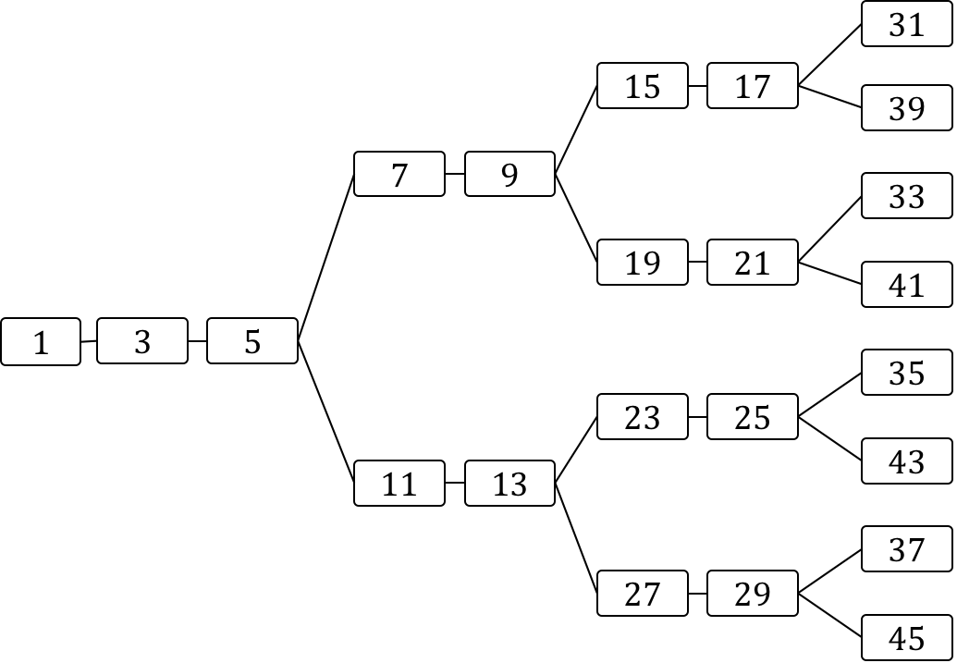
Introduction and story set-up. E.g. “You are a dinosaur hunter. You work for the Museum of…” etc.
1st Choice
2nd Choice
3rd Choice and End
2nd Choice
3rd Choice and End
3rd Choice and End
3rd Choice and End

Choices

The series name, Atama ii, means “smart” in Japanese. This is appropriate, because the series focuses very clearly on providing interesting, logical, and consequential choices to the reader, and is therefore suitable for basic critical thinking and discussion-based classroom activities. Never should the Atama-ii reader be presented with empty, random choices such as Do you open the door on the left or the door on the right? Rather, every choice is given a logical, meaningful setup, even if a simple one.

For example:

You are a castaway on a deserted island. You have washed up on the beach, with only the clothes on your back. From the position of the sun, you see that it is late afternoon. There are some dark clouds in the horizon. You are very thirsty and tired. Also, it is starting to get cold.

Do you look for water to drink? Or do you try to make a shelter for the night?

As you can see, there is no correct choice. One reader could easily argue that finding water is the most important thing to do first, while another could say that a shelter is the priority. From that choice, a variety of options and consequences will open up as the story progesses. Some consequences aren’t entirely predictable, of course—at this point in the story we don’t know if it will actually rain or not—but as long as the consequences are coherent and congruent, the story will be enjoyable and, most importantly, re-readable.

Submission Guidelines

Anyone may submit an original story for consideration by our editors. Please follow the step-by-step guidelines on our website. <atama-ii.com>

Thank you.

